Wire Compost Bin Instructions
Setting Up the Compost Bin
If available, a shady location is the best. It’s a good idea to put down a layer of black plastic or weed block material to keep tree roots from growing up into the compost.
To set up the compost bin untie the 3 nylon braid ties and unroll the wire. Walking on the wire will help flatten it and make it easier to form into a round bin.
Overlap the ends by at least one rectangle of the fence. Tie one end of the tie to the overlapping wires near the top of the bin and the wrap the tie around the wire and tie the end as shown below. Repeat this tying process in the middle and the bottom of the bin.
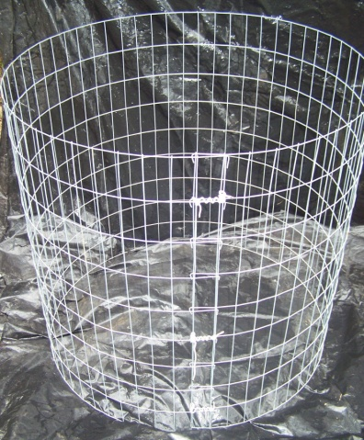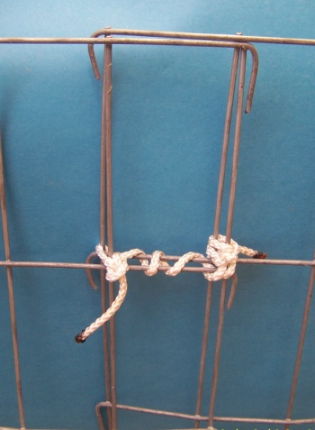
Filling the Bin
You can compost grass, leaves, weeds, food scraps and paper. Milk products and meat can be composted but they may attract animals. The most important part of composting is getting the moisture correct. Leaves should be wetted as they are added to the bin. Raking leaves after a rain is a good way to insure the leaves are wet enough to compost. If you add dry leaves, add water with every 3 or 4 inches of leaves you add to the bin. Grass, green weeds, and food scraps have enough moisture to compost without adding water. Paper is made from trees so coffee filters, paper towels, napkins, and paper plates all can be added to the compost bin. It is a good idea to cover food scraps with some leaves to reduce their attractiveness to animals. You do not have to turn the compost pile. It will compost on its own.
Harvesting Your Compost
Once the bin is full it will take 3 to 6 months for the composting process to finish. One option is to have 2 bins so you can be finishing one bin while filing the second bin. A second option is to pull the compost bin up over the compost pile and place it on a new piece of plastic. The pile should hold its shape and continue to compost without the wire.
Most of the material you add to the compost bin will go away during the composting process. If you fill a 3 foot bin, you will get 4 to 8 inches of compost when the process is finished.
Feel free to contact Paul Still at 904 368-0291 or stillpe@aol.com if you have any questions.
Compost bins are available from the Coalition for Peace and Justice for a$15 donation.

